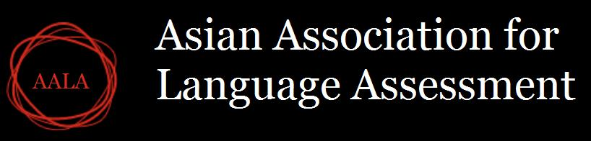

7th AALA WORKSHOP AND CONFERENCE REGISTRATION FORM

1. Make your payment through PayPal on the AALA site.

2. Complete the form on this file by filling in values and send it as an e-mail attachment to
aalaconf@eiken.or.jp upon making your payment.

3. Presenters of posters and papers are required to complete the registration, including fee
payment, before October 10, 2021 to confirm their attendance. Presentation slots not confirmed by October 10 will be reassigned or cancelled.

Type of participant | Rate in USD | Your payment
Regular Conference Registration
Regular | 40
Student | 20
Regular Workshop Registration
Regular | 30
Student | 15
Total
 |  | $0

Name:
Email:

